|  |
| --- |
| **PRACTICE REPORT ENGLISH II**  **DESCRIBING CHARTS** |
|  |
| **Agus Pranata Marpaung**  **13323033**  **DIII COMPUTER ENGINEERING** |
| **DEL INSTITUTE OF TECHNOLOGY**  **VOCATIONAL FACULTY** |

1. **Classification:**

Males: In the period from 2015 to 2020 in the UK, 32% were arrested and 68% were not arrested. Females: During the same period, 9% of females were arrested and 91% were not arrested.

**Description:**

The image displayed two pie charts that represented data on the percentage of people arrested in the UK from 2015-2020. Each chart was divided into two segments, indicating those who were arrested and those who were not. The left chart was labeled “Males” and showed that 32% were arrested while 68% were not. The right chart was labeled “Females” and indicated that 9% were arrested while 91% were not. Both charts had a dark blue color for the “Arrested” segment and a lighter blue shade for the “Not Arrested” segment. The charts provided a clear visual representation of the gender distribution of arrests.

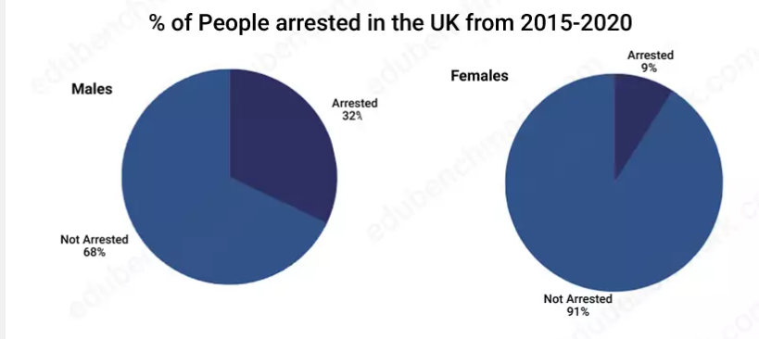

1. **Classification:**

* Drink Driving: Men participate more than women.
* Public Intoxication: Men participate more than women.
* Breaking and Entering: Participation is similar for both genders.
* Assault: Participation is similar for both genders.
* Theft: Participation is similar for both genders.
* Other: Participation is similar for both genders

**Description:**

The bar chart depicted a comparison of the percentages of men and women involved in various offenses. Five types of offenses were listed on the x-axis: Drink Driving, Public Intoxication, Breaking and Entering, Assault, Theft, and Other. The y-axis represented the proportion of each gender involved in these offenses, with percentages ranging from 0 to 40. The bars for men were colored darker, while those for women were lighter. Men had higher percentages in Drink Driving and Public Intoxication, while women had slightly lower percentages. For the offenses of Breaking and Entering, Assault, Theft, and Other, both genders showed similar percentages. The chart provided a clear visual representation of the gender distribution for each type of offense.

